

SCHOOL OF ENGINEERING AND TECHNOLOGY

A Report On
“Used Gadgets Price Prediction”

Submitted in partial fulfilment of the requirements for the award of degree in

BACHELOR OF TECHNOLOGY IN
COMPUTER SCIENCE ENGINEERING

SUBMITTED BY-
Sourav S (20BBTCS143)
Yashwanth B N (20BBTCS166)

GUIDED BY-
Dr Manjunath C R
Professor, Dept of CSE/IT,
SoET CMRU, Bengaluru.

Department of Computer Science and Engineering Off Hennur - Bagalur Main Road,Near Kempegowda International Airport, Chagalahatti,
Bangalore, Karnataka-562149 2023-2024



SCHOOL OF ENGINEERING AND TECHNOLOGY
Chagalahatti, Bengaluru, Karnataka-562149
Department of Computer Science and Engineering

CERTIFICATE

This is to certify that the Machine Learning [4BCS701] Report entitled “Used Gadgets Price Prediction” has been successfully carried out by Sourav S (20BBTCS143) and Yashwanth B N (20BBTCS166) in partial fulfilmentof the requirement in Machine Learning [4BCS701] course for the award of the degree Bachelor of Technology in Computer Science of CMR University, Bangalore in the course of Machine Learning during the academic year 2023- 2024.The report has been approved as it satisfies the academic requirements.

CIE Marks

Max. Marks | Marks Awarded

Signature

_ _ _ _ _ _ _ _ _ _ _ _ Dr Manjunath C R Professor, Dept of CSE/IT

Table of Content

Chapter No | Content | Page No
 | Abstract | iii
1 | Introduction | 1
2 | Comparative Study on Existing Methodology | 8
3 | Methodology | 11
4 | Conclusion | 18
5 | Bibliography | 19

i

Table of Figure

Figure No | Figure | Page No
1.1 | Resale Market | 1
1.2 | Variance in Market | 2
1.3 | Different types of Gadgets | 3
2.1 | Actual vs Predicted prices using RF model | 8
3.2 | Structure of Proposed DNN | 9
2.3 | Triangle correlation | 10
3.1 | Data Splitting | 11
3.2 | Methodology | 14
3.3 | Block Diagram | 15
3.4 | Dataset | 15

ABSTRACT
The trade of used electronics devices plays vital role towards the growth of economy of the nation. In recent years, the commercial field has adopted many technological transformations, except for the used electronics. Moreover, the amount of market data is also increasing at an exponential rate. Price prediction of goods is a vital point of research due to how common e-commerce platforms are. There are several efforts conducted to forecast the price of items using classic machine learning algorithms and statistical models. These models can predict prices of various financial instruments, for example, gold, oil, cryptocurrencies, stocks. Despite these efforts, literature has no model for predicting the prices of used gadgets or second-hand devices.
This report presents a comprehensive methodology for used gadgets price prediction using various machine learning algorithms. This report begins by discussing the importance of used gadgets' price prediction and its potential impact on the resale market. It highlights the challenges associated with price prediction, including the data quality and availability and heterogeneity of gadgets. The report aims to analyze the research published on Methodology in price prediction over the past years. Moreover, reviews of techniques for price prediction are presented. This report aims at building and evaluating machine learning models for used gadgets price prediction including Regression, Machine Learning, Gradient Boosting models like XGBooster, LightGBM.

Here we focus on designing and comprehensive study on Prediction model, by combining the outputs of individual regression models and gradient boosting models. Overall, it is expected that this study will facilitate knowledge accumulation and creation of price prediction and provide readers, researchers, and practitioners a roadmap to guide future direction. In this case study, the focus rests on machine learning models to estimate the best price for the devices, which is more reliable when considered to other methods.

Keywords— Used gadgets, Price Prediction, Machine Learning, Lasso Regression, Elastic Net Regression, Kernal Ridge Regression, Gradient Boosting

iii

Chapter 1

INTRODUCTION

Today, making a decision about buying or selling any assets or gifts is a very difficult process. A lot of factors and complexities can influence your decision, such as the best time for buying or selling the products, goods, or seasonal gifts. In the financial market, the shareholders need to know when to sell, and the customers need to get the products at good prices. Thus, the price prediction issue has arisen. Price forecasts for trading stocks and commodities were primarily based on intuition. As trading grew, individuals tried to find methods and tools which could accurately forecast the rates, increasing their gains and reducing their risk. Many methods such as fundamental analysis, technical analysis, information mining, statistical approaches, and machine learning techniques are used for price prediction. The most hopeful results of forecast systems might be a shift in people’s state of minds.


Fig.1.1 Resale Market
As discussed above, several methods can be used to resolve the price forecast issues, but We will focus on only two: statistical models and machine learning models. There are plenty of machine leaning models for evaluating and forecasting costs. Machine learning models can gain from historic correlation and patterns in the data to make data-driven forecasts or choices.

Regression analysis is widely used for forecasting and prediction, where its use has a high degree of overlap with machine learning. Regression analysis is likewise used to find the function that maps the independent variables to the predicted (i.e., dependent) variable, and to find out the forms of these relationships/functions. In limited circumstances, it can be used to identify causal functions/relationships between the independent and dependent variables. In many applications, particularly with little results or concerns of causality based upon observational data, regression techniques can provide deceptive outcomes. Regression designs for forecast are often helpful even when the assumptions are reasonably breached, although they might not be carried out optimally.



Fig.1.2 Variance in market
Research scholars have focused extensively on the problem of price prediction and price forecasting of different commodities by using diverse forecasting methods; the relevant applications include oil price forecasting, electricity price forecasting, stock price forecasting, coal price prediction, house price prediction, Bitcoin price forecasting, car price prediction, price prediction of ecommerce items, and price prediction of second-hand cars. However, the price prediction of second-hand ecommerce items has not been widely addressed.
Several methods can be used to address the fore mentioned problems, and these methods can be divided into two categories: statistical models and machine learning models. The methods can also be classified based on the utilized approach, i.e., machine learning (ML) and time series. In addition, the methods can be classified based on the data type, i.e., tabular and non-tabular data, text, image, product reviews, and trends.

Many researchers have explored the problem of price prediction issues with the aid of various machine learning approaches. For example, forecast the carbon price utilizing the LSTM model on a real dataset of China. Some used three machine learning methods: Artificial Neural Network (ANN), SVR, and random forest on cars and truck rate predictions. In one such example, the researchers utilized many machine learning methods to forecast the rate of air travel (e.g., Multilayer Perceptron (MLP), Extreme Learning Device (ELM), random forest, bagging regression trees, and direct regression).

Statistical methods for price prediction problems were predicting next-day electricity prices based on the ARIMA methodology. Some researchers proposed using the ARIMA model

and the SVMs model in forecasting stock prices. Several research works utilized the ARIMA model for the task of price prediction.
In the literature, many studies have focused on price prediction for a variety of financial instruments (e.g., stocks and gold), using a variety of forecasting techniques. Examples include price forecasting for coal, electricity, natural gas, houses, cars, prediction of Bitcoin prices, and second-hand ecommerce price projection.

Despite many efforts, there is no reliable existing research providing a model for predicting the prices of used gadgets, to our best knowledge. Thus, there is a vital need for models that can predict the prices of these used gadgets and the ability to compare the performance of various machine learning models. These proposed models can help the seller evaluate the proper pricing, based on historical data. Historical data of these gadgets pricing can guide the seller to select the most suitable prices.


Fig.1.3 Different types of gadgets

In this vein, we framed the task of predicting the price of these used and second-hand gadgets as a regression task. We proposed a system for predicting the prices of these items using both machine learning methods and statistical methods. The proposed system utilized a real-life dataset. In addition, the proposed work utilized a set of machine learning models and statistical models. The proposed models are thoroughly evaluated on different evaluation metrics.

The report is organized in the following manner:

- Introduction provides an overview of the proposed price prediction model for used gadgets.
- Background includes the overview of previously performed studies on price prediction models of various goods and commodities, used, second-hand and seasonal goods.
- Further, we provided a comparison between various machine learning-based models to learn which model performs better.
- The proposed models are evaluated on several performance evaluation metrics.
- Finally, the best price is provided.

Applications
    - Dynamic Pricing: E-commerce platforms can use price prediction models to dynamically adjust the prices of second-hand gadgets based on market demand, supply, and other factors, optimizing revenue and competitiveness.

    - Fair Pricing: In platforms where individuals sell directly to other consumers, a price prediction model can help sellers set fair and competitive prices for their used gadgets, enhancing trust and transaction success.

    - Trade-in Valuation: Retailers offering trade-in programs for used gadgets can use price prediction models to assess the value of devices accurately, providing customers with fair trade-in values.

    - Claims Assessment: Insurance companies can leverage price prediction models to evaluate the value of damaged or lost gadgets in insurance claims, facilitating faster and more accurate claims processing.

    - Optimized Bidding: Users on auction platforms can benefit from a price prediction model by making informed decisions on bidding strategies, considering the predicted value of the second-hand gadgets.

    - Listing Assistance: Individuals listing their gadgets for sale on classified websites can receive guidance on appropriate pricing, improving the chances of attracting potential buyers.

    - Upgrade Valuation: Mobile carriers and device manufacturers offering upgrade programs can use price prediction models to determine the value of the customer's current device, influencing upgrade incentives.

    - Inventory Management: Retailers can optimize their inventory of second-hand gadgets by using price prediction models to anticipate market trends and adjust stock levels accordingly.

    - Asset Valuation: Individuals and businesses can use the model to estimate the value of their used gadgets for financial planning purposes, such as budgeting, depreciation calculations, or asset management.

    - Seller Guidance: Users selling gadgets on social media platforms can benefit from price prediction models by receiving suggestions on competitive pricing, enhancing the chances of successful transactions.

    - Resource Allocation: Refurbishment centers can optimize their operations by predicting the resale value of gadgets, guiding decisions on which devices to refurbish and allocate resources effectively.

Implementing a second-hand or used gadgets price prediction model in these applications can lead to more informed decision-making, improved customer satisfaction, and better overall efficiency in the market for pre-owned electronic devices.

A machine learning model predicting second-hand gadget prices has broad applications. It optimizes pricing on e-commerce platforms, ensures fair valuations for consumers and trade- ins, aids insurance claims, enhances auction bidding, guides sellers on social media platforms, optimizes inventory for retailers, aids financial planning, and supports environmental sustainability by promoting electronics reuse. In summary, it improves decision-making and user experience across various industries.

Challenges

    - Data Quality and Availability: Obtaining high-quality, relevant, and sufficient data for training the model can be challenging. Incomplete or biased datasets may lead to inaccurate predictions.

    - Feature Selection and Engineering: Identifying the most relevant features and creating meaningful input variables can be complex. The model's accuracy heavily depends on selecting the right predictors.

    - Dynamic Market Conditions: The market for second-hand gadgets is dynamic, with prices influenced by various factors such as seasonality, trends, and economic conditions. Adapting the model to these changes can be challenging.

    - Heterogeneity of Gadgets: Second-hand gadgets come in various conditions, brands, and models. Developing a model that accurately predicts prices across this heterogeneity is challenging, and it requires careful consideration of different categories.

    - Data Privacy and Security: Handling sensitive information about gadgets and users raises concerns regarding data privacy and security. Ensuring compliance with regulations and safeguarding user data is essential.

    - Overfitting and Generalization: Balancing the model's ability to fit the training data while avoiding overfitting is crucial. Ensuring that the model generalizes well to unseen data is a continuous challenge.

    - Interpretable Models: Some machine learning models, particularly complex ones

like deep neural networks, may lack interpretability. Understanding and explaining the model's predictions is important, especially for user trust and regulatory compliance.

    - Model Evaluation Metrics: Choosing appropriate evaluation metrics is critical. Accuracy alone may not be sufficient, and considerations such as precision, recall, or business-specific metrics need to be considered.

    - Scalability: Developing a model that can scale to handle a large volume of transactions and data is essential for real-world applications. Scalability issues may arise as the dataset grows.

    - User Adoption and Trust: Users may be skeptical about trusting price predictions, especially if the model's decision-making process is not transparent. Building user trust and ensuring user adoption is a significant challenge.

    - Market Anomalies and Outliers: Unusual market conditions or outliers in the data can significantly impact model performance. Handling these anomalies robustly is essential for model reliability.

Addressing these challenges requires a thoughtful and iterative approach to model development, including continuous monitoring, refinement, and adaptation to evolving market conditions and user needs. Collaboration between data scientists, domain experts, and stakeholders is crucial for building a successful and reliable second-hand gadgets price prediction model.

Problem Statement
We live in a world that is driven by technology and electronic devices as gadgets have become a part of our daily life. It is near impossible to think of a world without smartphones or tablets. Like many kinds of goods or products, used electronic devices have a good demand in our country. In this project, we aim to predict the price of used electronic devices based on certain factors using various machine learning and statistical models.
The aim of the project is to predict the price of used and second-hand gadgets using supervised learning and using some hypothesis-testing techniques to validate the project.

Proposed Model

The proposed model composites various machine learning algorithms like Lasso Regression, Elastic Net Regression, Kernal Ridge Regression and Gradient Boosting like XGBoost and LightGBM.

    - Data Collection: Gather relevant data from various sources.

    - Preprocessing: Clean and preprocess the data to handle missing values, outliers, and inconsistencies. Perform feature engineering to create meaningful features that capture essential aspects of the gadgets.

    - Feature Selection: Identify the most relevant features that contribute to giving the best

price. Use techniques such as uni-variate analysis, used to describe data. The analysis will take data, summarize it, and then find some pattern in the data.

    - Model Selection: Choose machine learning algorithms based on the nature of the problem. Commonly used algorithms for price prediction include:

      - Lasso Regression
      - Elastic Net Regression
      - Kernal Ridge Regression
      - Gradient Boosting (e.g., XGBoost, LightGBM)

    - Model Training and Evaluation: Split the dataset into training and validation sets for model training and evaluation. Train the selected models on the training data, adjusting hyperparameters as needed. Use appropriate evaluation metrics (e.g., accuracy, precision, recall, classification) to assess the model's performance on the validation set. Fine-tune the model's hyperparameters to improve its performance. This can be done using techniques like grid search, random search, or more advanced optimization algorithms.

Objectives
- To comprehend various price prediction models.
- To design used gadgets price prediction model using machine learning algorithms.
- To analyze the estimated results.

Chapter 2

COMPARITIVE STUDY ON EXISTING METHODLOGY

Comprehending the various Price Prediction methodologies

Price Prediction of Seasonal Items Using Machine Learning and Statistical Methods
Authors: Mohamed Ali Mohamed, Ibrahim Mahmoud El-Henawy and Ahmad Salah
Year of Publish: 08 July 2021
Proposed Model: Support Vector Regression (SVR), ARIMA, Regression
In this paper, they proposed system of seasonal price prediction and framed the task of seasonal goods price prediction as a regression problem. They utilized a real online trailer
dataset of Christmas gifts and then we proposed several machine learning-based models and one statistical-based model to predict the prices of these seasonal products.

Steps involved in proposed methodology
      - Data collection and preparation
      - Model designing
      - Training the models
      - Testing the models
      - Deploying the models.
They used various regression models like Support Vector Regression, Ridge regression, Random Forest, Linear Regression and ARIMA model.

Limitations:
      - Limited data
      - Data quality and quantity and Outliers

Results
The obtained results show that the best results are obtained from the random forest model, followed by the ARIMA model with a small margin of performance gap. This study recommends the Random Forest machine learning-based model and the ARIMA
statistical-based model to address the problem of predicting seasonal goods’ pricing.
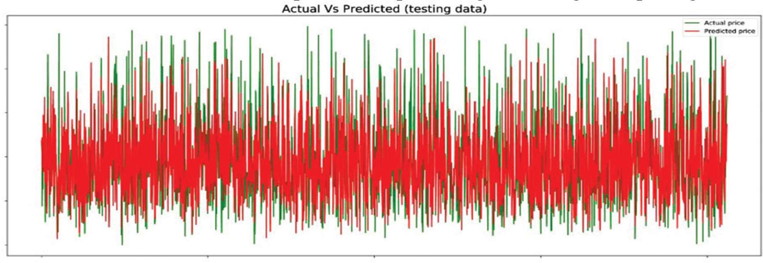

Fig 2.1 The actual vs. the predicted prices using random forest model

Prediction of Electronic Component Prices: from Classical Statistical and Machine Learning Models to Deep Neural Networks with Feature Embedding
Authors: Zhang Yu

Year of publish: 2019
Proposed Model: Statistical model, DNN

This study explores the relationship between unit prices and their associated specifications and purchase details of electronic components. Classical statistical and Machine Leaning (ML) models as well as Deep Neural Networks (DNN) are then built to capture the underlined relationship and predict the unit price of any given electronic component. The performance of these models is thoroughly compared, and the optimal model is selected, which could provide strong data-driven support for the decision-making process of the customers.

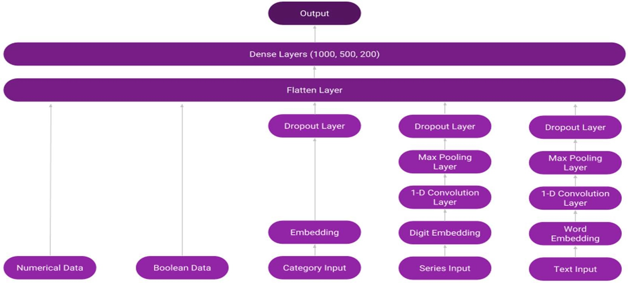

Fig.2.2 Structure of the proposed DNN

    - Limitations:
      - Model complexity.
      - Overfitting
      - Missing values in dataset.
      - Sensitivity of models towards missing values and outliers.

Results:
The results show that the nonlinear models such as SVM, k-NN, RF and XGB significantly outperform the Naive baseline model and OLS model, indicating strong nonlinear relationship between the electronic component unit prices and their specifications and purchase details. It is observed that RF and XGB models have considerable overfitting issues
over the SVM and k-NN models; however, they still achieve the optimal performance in terms of the least RMSE and smallest PIs of ROPV in the CV procedures. Thus, they are deemed as the optimal models among the classical statistical and ML models.

Predicting the Price of Used Electronic Devices Using Machine Learning Techniques
Authors: Muhammad Hasnain, Abdul Sajid, M. Arshad Awan

Year of publish: 1 July 2023
Proposed model: Linear regression, multilayer perceptron and Random Forest

In this paper, they proposed a machine learning based approach to predict the selling price. The model considers various characteristics of the device and its usage history to predict its price. These characteristics are extracted from a dataset that contains information about different cell phones, such as brand, model, storage capacity, screen size, as well as the number of previous owners. In this paper, the data used on smartphone pricing was collected by web scraping from e-commerce and online websites i.e. www.whatmobile.com and www.olx.com.pk.
In this research, they focused on supervised machine learning to predict the selling price. Using the labeled dataset, a predictive model was built to determine a numerical variable, the selling price of a used cell phone, based on the output and input data.
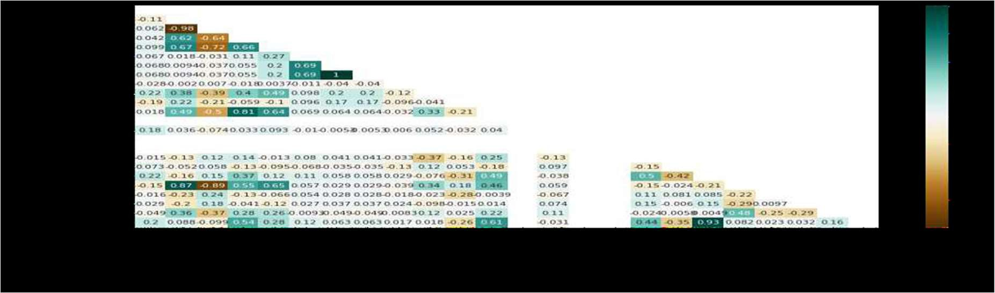

Fig.2.3 Triangle Correlation
The main objective of our paper is to predict the price of used smartphones based on the recorded attributes. In this paper, Linear regression, multilayer perceptron and random forest algorithms were selected, because they have high prediction accuracy on numerical data. The performance of the model was evaluated using metrics such as mean absolute error (MAE), root mean square error (RMSE), relative absolute error (RAE) and relative square error (RRSE).

Result:
They concluded that the Random Forest model performs better than the other models in those experiments.

Chapter 3

METHODLOGY

In the typical machine learning process, data is typically split into training and test sets. The purpose of the training set is to train the model, while the test set is used to assess the model's performance. Nonetheless, this approach can introduce variance issues. To put it simply, a variance problem occurs when the accuracy achieved on one test set greatly differs from the accuracy achieved on another test set using the same algorithm.
The solution to this problem is to evaluate performance using K- Fold, Cross-Validation, where K represents any number. The process of K-Fold Cross-Validation is simple. The data is divided into K folds, with K-1 sets used for training and the remaining set used for testing. The algorithm is trained and tested K times, with each iteration using a new set for testing and the remaining sets for training. Ultimately, the result of the K-Fold Cross-Validation is determined by averaging the results obtained from each set.
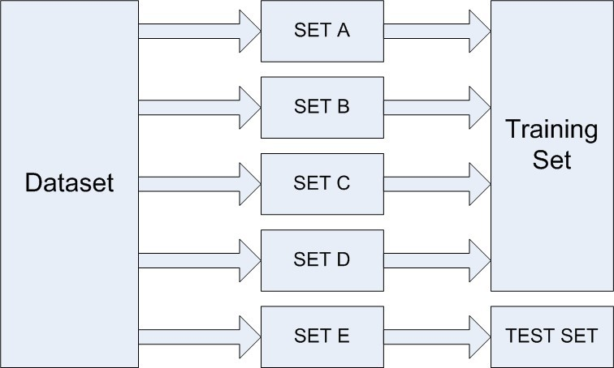

Fig.3.1 Data Splitting

K-Folds cross-validator provides train/test indices to split data in train/test sets. Split dataset into k consecutive folds (without shuffling by default). Each fold is then used once as a validation while the k - 1 remaining folds form the training set.

Syntax:
class sklearn.model_selection.KFold(n_splits=5, *, shuffle=False, random_state=None)
Let K: {1, ...., N}-> {1, , K} be an indexing function that indicates the partition to which
observation i is allocated by the randomization. Denote by the fitted function, computed with the kth part of the data removed. Then the cross-validation estimate of prediction error is
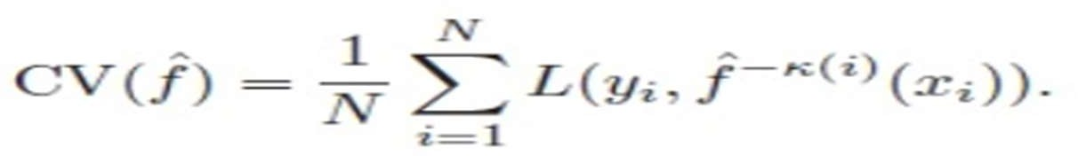
. 3.1
The case K = N is known as leave-one-out cross-validation. In this case K(i)=i, and for the ith observation the fit is computed using all the data except the ith.

KFold divides all the samples into k groups of samples, called folds (if k=n, this is equivalent to the Leave One Out strategy), of equal sizes (if possible). The prediction function is learned using k-1 folds, and the fold left out is used for test.
cross_val_score is a function that generates a cross-validated accuracy score for each data point of our dataset. It splits the data set into multiple subsets of training and testing data, trains the model on each training subset, performs predictions on the testing subset, and outputs the prediction accuracy score for each subset. The process repeats depending on the number of cross-validations we have set.
The cross_val_score function evaluates the model's performance on each data point, providing a better understanding of the model's behavior and weaknesses.

Syntax:
cross_val_score (estimator, x, y, groups, scoring, cv, n_jobs, verbose, fit_params, pre_dispatch, error_score)

Root Mean Square Error represents the square root of the average squared differences between predicted and observed outcomes. It is a metric predominantly utilized in regression analysis and forecasting, where accuracy matters significantly. The lower the RMSE, the better the model’s ability to predict accurately. Conversely, a higher RMSE signifies a greater discrepancy between the predicted and actual outcomes.

RMSE = sqrt [(Σ (Pi – Oi) ²) / n] 3.2
Here, Pi denotes the predicted value, Oi represents the observed value, and n is the total number of observations or data points. The sum of the squared differences between the predicted and observed values is divided by the number of observations, and the square root of the result is taken to yield the RMSE. This calculation serves as a measure of the differences between values predicted by a model and the values observed in reality.

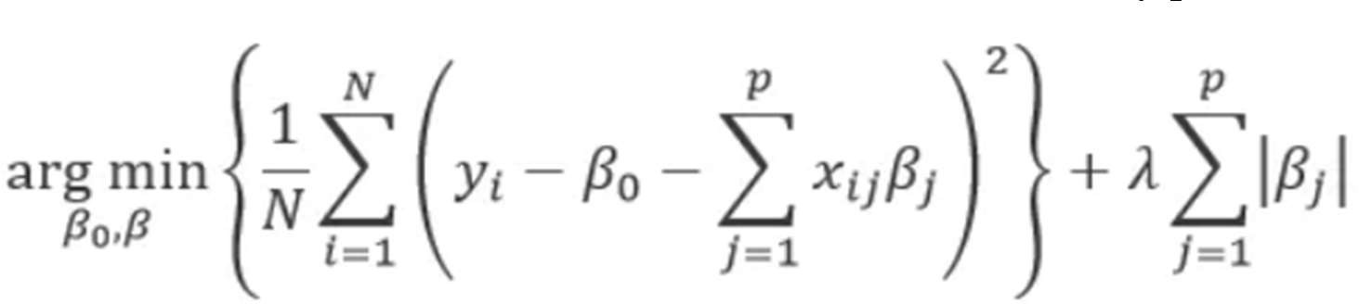
In LASSO (Least Absolute Shrinkage Selector Operator) regression, a regularization term of “sum of the absolute value of the coefficients” is added to the cost function. Lasso trims down the coefficients of redundant variables to zero and thus directly performs feature selection also.

. 3.3

Thus, the cost function for both ridge and lasso in generalized form is given by:

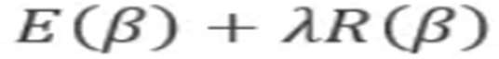 …………………………………………………….. 3.4
Here E(β) is Error term and R(β) is Regularization term. If we use high value of λ, we are putting lot of premiums on controlling complexity of model. It will not allow coefficients to be

large at all. If we allow λ close to zero, implies that there is no regularization and there is a high chance of overfitting. Here λ is the hyper parameter in the objective function that we minimize for regularized regression.

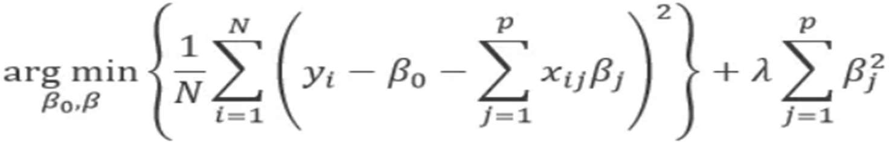
In Ridge regression, an additional term “sum of squares of the coefficients” is added to the cost function. Ridge regression essentially does is to try to minimize the sum of the error term along with sum of squares of coefficients which we try to determine. The sum of the squares of the coefficients is called as ‘regularization term’ and it also has the regularization coefficient denoted by λ.

……… 3.5

The coefficient values of the above cost function are determined by the following closed form solution.
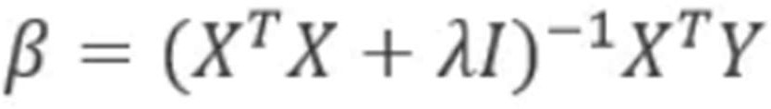
………………………………………. 3.6

Algorithm of the proposed approach:
- Gather a diverse dataset of second-hand gadgets or used gadgets with their features like model, storage, RAM, etc.
- Identify suitable Variables and perform Univariate Analysis, Bi-variate Analysis, Remove missing values and Outliers, Variable transformation, dummy variable creation.
- Divide the dataset into training, validation and test sets for model training and evaluation.
- Build base models using algorithms like Lasso Regression, Elastic Net Regression, Kernal Ridge Regression and Gradient Boosting models and XGBoost and LightGBM.
- Train the models on training dataset and evaluate scores of each model.
- Calculate the average of Lasso, ENet Regression, KRR and GBoost models to combine them into stacked model.
- Apply the models on test data to get estimated price from stacked model, XGBoost and LightGBM models.
- Apply a formula to calculate a final single price of the gadgets in the form of excel sheet(.xlsx).

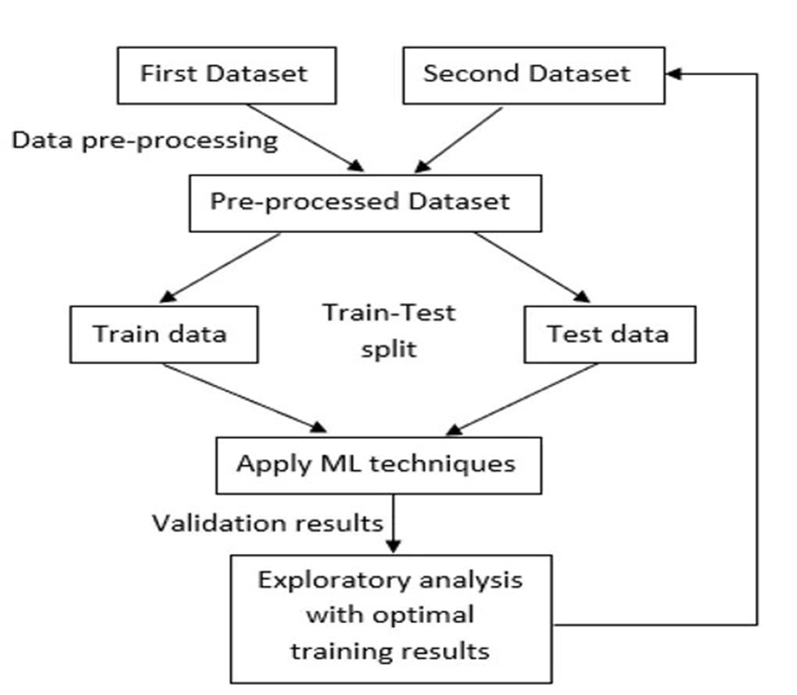
Fig.3.2 Methodology

Procedure of the proposed approach:
Data Collection:
Gathering a diverse dataset of second-hand and used gadgets based on various features. A large scale of data is required to train the models.

Preprocessing:
Data normalization, missing data and outliers, classifications to be considered. Feature engineering is carried out to extract relevant features like Brand, RAM, Device condition, Warranty.

Model Deployment:
Build and use Base models like Lasso Regression, Elastic Net regression, Kernal Ridge Regression and Gradient Boosting models along with XGBoost and LightGBM.
Split dataset into training and test sets. Train the model using training dataset. Combine the models into a single averaged stack model.
Evaluation:
Validate the stacked model, XGBoost and LightGBM on test dataset to get estimated prices and performance. Generate an individual excel sheet for ech model. Apply formula to get final estimated price in excel sheet form.

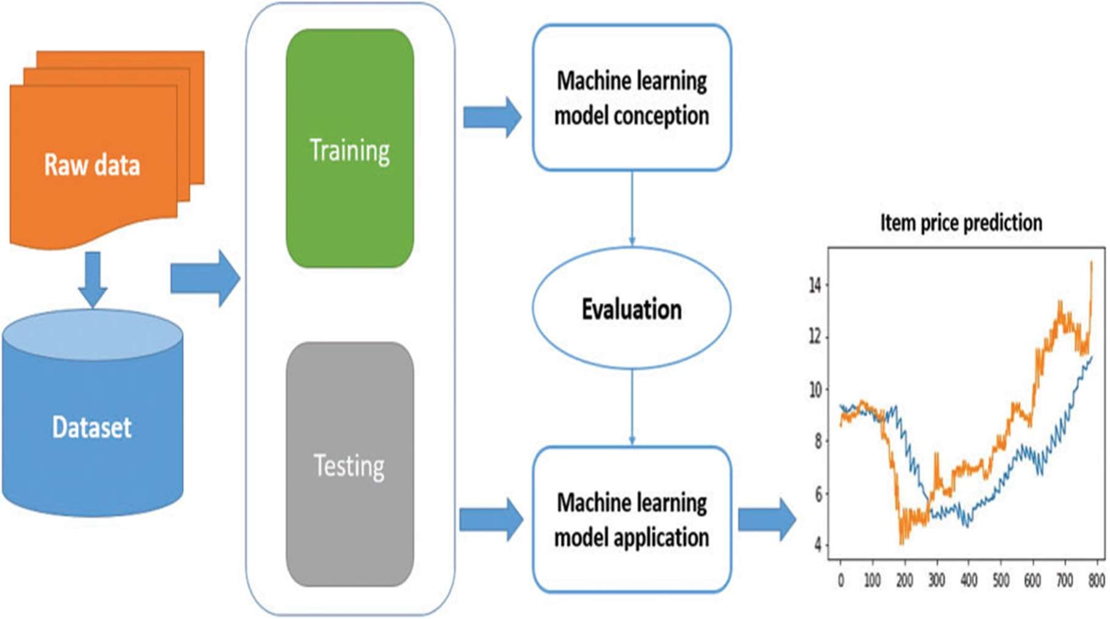
Fig.3.3 Block Diagram

Data Set
The dataset needed for Used gadgets price prediction is large. The training dataset consists of 2326 observations and the test dataset consists of 997 observations. The data within a dataset for a second-hand gadgets price prediction model is critical for the model's effectiveness. The data consists of Brand, Model Info, Additional Information, RAM size, Condition of device, Locality, City, Warranty, Bill box and other information like Color, refurbished or not, time, number of users, etc. The target variable is Price. Compromising all this information, this dataset forms the foundation for training and testing of model, aiming to give best price for the gadgets.
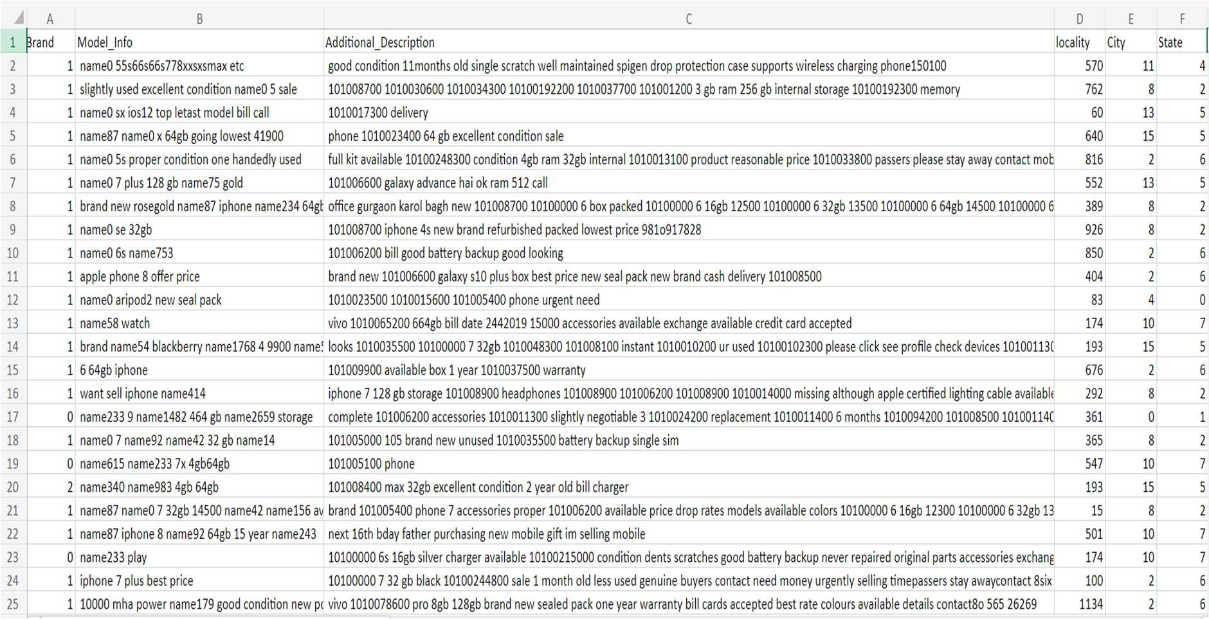
Fig.3.4 Dataset

Algorithms Used

We used various regression and gradient boosting models on this dataset to ensemble the regression models and find better price of the gadgets. They are given below with a short description.

LASSO Regression
Lasso regression is a regularization technique. It is used over regression methods for a more accurate prediction. This model uses shrinkage. Shrinkage is where data values are shrunk towards a central point as the mean. The lasso procedure encourages simple, sparse models (i.e. models with fewer parameters). This particular type of regression is well-suited for models showing high levels of multicollinearity or when you want to automate certain parts of model selection, like variable selection/parameter elimination.
The primary goal of LASSO regression is to find a balance between model simplicity and accuracy. It achieves this by adding a penalty term to the traditional linear regression model, which encourages sparse solutions where some coefficients are forced to be exactly zero. This feature makes LASSO particularly useful for feature selection, as it can automatically identify and discard irrelevant or redundant variables.

Elastic Net Regression
Elastic net linear regression uses the penalties from both the lasso and ridge techniques to regularize regression models. The technique combines both the lasso and ridge regression methods by learning from their shortcomings to improve the regularization of statistical models.
The elastic net method improves lasso’s limitations, i.e., where lasso takes a few samples for high dimensional data. The elastic net procedure provides the inclusion of “n” number of variables until saturation. If the variables are highly correlated groups, lasso tends to choose one variable from such groups and ignore the rest entirely.
      - The elastic net method performs variable selection and regularization simultaneously.
      - The elastic net technique is most appropriate where the dimensional data is greater than the number of samples used.
      - Groupings and variables selection are the key roles of the elastic net technique.

Kernal Ridge Regression
Kernel Ridge Regression (KRR) is a type of regression algorithm that combines the principles of Ridge Regression with the use of kernel methods. Ridge Regression is a linear regression technique that introduces a regularization term to prevent overfitting, and kernel methods allow for nonlinear transformations of the input data.
Ridge Regression is an extension of linear regression that aims to address the problem of multicollinearity and overfitting. It introduces a regularization term to the linear regression objective function. This term penalizes large coefficients, helping to prevent the model from fitting the noise in the training data. Kernel methods are a set of techniques that enable algorithms to operate in a higher-dimensional space without explicitly calculating the coordinates of the data in that space. The kernel trick involves computing the dot product between data points in a higher-dimensional space without explicitly transforming the data into that space.
In Kernel Ridge Regression, the regularization term of Ridge Regression is extended using the kernel trick. The algorithm implicitly maps the input features into a higher-dimensional space

using a chosen kernel function (e.g., radial basis function, polynomial). After training the model, predictions for new data points are made by applying the same kernel transformation and using the learned linear regression weights.

Advantages:
      - KRR can capture nonlinear relationships between input features and the target variable.
      - The regularization term helps prevent overfitting, making the model more robust.

Gradient Boosting Regression
Gradient boosting is a machine learning technique used in regression and classification tasks, among others. It gives a prediction model in the form of an ensemble of weak prediction models, i.e., models that make very few assumptions about the data, which are typically simple decision trees. When a decision tree is the weak learner, the resulting algorithm is called gradient-boosted trees; it usually outperforms random forest. A gradient-boosted trees model is built in a stage-wise fashion as in other boosting methods, but it generalizes the other methods by allowing optimization of an arbitrary differentiable loss function.
Benefits:
      - Frequently delivers unequaled accuracy in making predictions.
      - Multiple hyperparameter tuning options and the ability to optimize on a variety of loss functions make the function fit exceedingly adaptable.
      - No data pre-processing is necessary; category and numeric values generally perform admirably as-is.
      - Handles missing data; imputation is unnecessary.

CONCLUSION

The ensemble of second-hand price prediction models, including Lasso regression, Elastic Net regression, Kernel Ridge regression, Gradient Boosting models, XGBoost, and LightGBM, offers a versatile toolkit for addressing the complexities of predicting prices in the resale market. Each model brings its strengths and limitations to the table, and the selection should be guided by specific use-case requirements. The comprehensive ensemble of regression and boosting models provides a powerful solution for second-hand price prediction, catering to a wide range of scenarios and offering flexibility in balancing accuracy, interpretability, and scalability. The success of these models lies in their careful selection, thoughtful tuning, and ongoing refinement to meet the specific demands of the dynamic resale market.

BIBLIOGRAPHY

- Mohamed Ali Mohamed, Ibrahim Mahmoud El-Henawy and Ahmad Salah, “Price Prediction of Seasonal Items Using Machine Learning and Statistical Methods”, 2021.
- Ahmed Fathalla, Ahmad Salah, Kenli Lil, Keqin Li1, Piccialli Francesco, “Deep end-to-end learning for price prediction of second-hand items”, 2020.
- Zhang Yu, “Prediction of Electronic Component Prices: from Classical Statistical and Machine Learning Models to Deep Neural Networks with Feature Embedding”, 2019.
- Muhammad Hasnain, Abdul Sajid, M. Arshad Awan, “Predicting the Price of Used Electronic Devices Using Machine Learning Techniques”, 2023.
- Varun Kiran, A. and Jebakumar, R. “Prediction of Mobile Phone Price Class using Supervised Machine Learning Techniques”,7 (1), 248-251, 2022.
- E. Güvenç, G. Çetin, and H. Koçak, “Comparison of KNN and DNN Classifiers Performance in Predicting Mobile Phone Price Ranges”, Advances in Artificial Intelligence Research, vol. 1, no. 1, pp. 19-28, Jan. 2021.
- Yu, P., & Yan, X. Stock price prediction based on deep neural networks. Neural Computing and Applications, 32(6), 1609-1628, 2020.
- Pal N, Arora P, Kohli P, Sundararaman D, Palakurthy SS, “How much is my car worth? A methodology for predicting used cars’ prices using random forest”. In: Future of information and communication conference. Springer, pp 413–422, 2018.
- Chandrashekhara, K. T., Thungamani, M., Gireesh Babu, C. N., & Manjunath, T. N., “Smartphone price prediction in the retail industry using machine learning techniques”. Emerging Research in Electronics, Computer Science and Technology, 363-373, 2019.
- Shastri M, Roy S, Mittal M, “Stock price prediction using artificial neural model: an application of big data”, 2019.
- Tseng KK, Lin RFY, Zhou H, Kurniajaya KJ, Li Q, “Price prediction of e- commerce products through internet sentiment analysis”. Electron Commerce Res 18(1):65–88,2018.
- Q. Wang, Y. Ma, K. Zhao and Y. Tian, “A Comprehensive survey of loss functions in machine learning,” Annals of Data Science, vol. 7, no. 2, pp. 1–26, 2020.

Appendix

[1]:
import pandas as pd
import numpy as np
import matplotlib.pyplot as plt
import seaborn as sns

[3]:
train = pd.read_csv(
r"C:\Users\soura\Desktop\capston project report\Train.csv"
)

train.head()

[5]:
import pandas as pd

train = pd.read_csv(r"C:\Users\soura\Desktop\capston project report\Train.csv") test = pd.read_csv(r"C:\Users\soura\Desktop\capston project report\Test.csv")

print(train.shape) print(test.shape)

train.head()

[9]:
train.isnull().sum()

[10]:
train.dtypes

[11]:
train.describe()

[12]:
train.info()

[14]:

import matplotlib.pyplot as plt

plt.figure(figsize=(14,5))

plt.subplot(1,3,1) train.Brand.value_counts().plot(kind='bar', label='Brand') plt.legend()

plt.subplot(1,3,2) train.City.value_counts().plot(kind='bar', label='City') plt.legend()

plt.subplot(1,3,3) train.State.value_counts().plot(kind='bar', label='State') plt.legend()

plt.show()

[15]:
train.Price.plot(kind='hist', color=['teal'], label="Price") plt.legend()
plt.show()

[16]:

def device_memory_category(x):
if (x.find("16gb") != -1) or (x.find("16 gb") != -1):
return 1
elif(x.find("32gb") != -1) or (x.find("32 gb") != -1):
return 2
elif(x.find("64gb") != -1) or (x.find("64 gb") != -1):
return 3
elif(x.find("128gb") != -1) or (x.find("128 gb") != -1):
return 4
elif(x.find("256gb") != -1) or (x.find("256 gb") != -1):
return 1
else:
return 0

def if_iphopne_or_ipad(x):
if (x.find("iphone") != -1) or (x.find("ipad") != -1):
return 1
else:
return 0

def device_condition(x):
if (x.find("good") != -1) or (x.find("great") != -1) or (x.find("excellent") != -1)
or (x.find("new") != -1) \
or (x.find("mint") != -1):
return 1
else:
return 0

def under_warranty(x):
if (x.find("billbox") != -1) or (x.find("warranty") != -1) or (x.find("boxbill") !=
-1) or (x.find("box") != -1) \
or (x.find("bill box") != -1):
return 1 else: return 0

[17]:
train["device_memory"] = train["Model_Info"].apply(lambda x: device_memory_category(x))
train["phone_status"] = train["Model_Info"].apply(lambda x: if_iphopne_or_ipad(x)) train["device_condition"] = train["Model_Info"].apply(lambda x: device_condition(x))
train["warranty_status"] = train["Additional_Description"].apply(lambda x: under_warranty(x))

[19]:
plt.figure(figsize=(14,5))

plt.subplot(2,2,1)
train.device_memory.value_counts().plot(kind='bar', label = 'device_memory') plt.legend()

plt.subplot(2,2,2)
train.phone_status.value_counts().plot(kind='bar', label = 'phone_status') plt.legend()

plt.subplot(2,2,3)
train.device_condition.value_counts().plot(kind='bar', label = 'device_condition') plt.legend()

plt.subplot(2,2,4)
train.warranty_status.value_counts().plot(kind='bar', label = 'warranty_status') plt.legend()

[21]:
train = pd.get_dummies(data=train, columns=['City','State','device_memory'],
prefix=['City', 'State', 'Device_memory'], drop_first=True)

[22]:
train['City_5'] = 0
train['City_6'] = 0
train['City_18'] = 0
train['City_19'] = 0

[25]:
train = train[['Brand', 'Model_Info', 'Additional_Description', 'Locality', 'Price', 'phone_status', 'device_condition', 'warranty_status', 'City_1',
'City_2', 'City_3', 'City_4', 'City_5', 'City_6', 'City_7', 'City_8', 'City_9', 'City_10',
'City_11', 'City_12', 'City_13', 'City_14', 'City_15', 'City_16',
'City_17', 'City_18', 'City_19', 'State_1', 'State_2', 'State_3', 'State_4', 'State_5',
'State_6', 'State_7', 'State_8', 'Device_memory_1', 'Device_memory_2',
'Device_memory_3', 'Device_memory_4']]

[27]:
x = train.drop(['Price', 'Model_Info', 'Additional_Description'], axis=1)
y = train['Price']

[29]:
from sklearn.model_selection import train_test_split
X_train, X_test, y_train, y_test = train_test_split(x, y, test_size = 0.2, random_state = 100)

[30]:
from sklearn.linear_model import ElasticNet, Lasso, BayesianRidge, LassoLarsIC from sklearn.ensemble import RandomForestRegressor, GradientBoostingRegressor from sklearn.kernel_ridge import KernelRidge
from sklearn.pipeline import make_pipeline
from sklearn.preprocessing import RobustScaler
from sklearn.base import BaseEstimator, TransformerMixin, RegressorMixin, clone from sklearn.model_selection import KFold, cross_val_score, train_test_split from sklearn.metrics import mean_squared_error

[31]:
import xgboost as xgb

[32]:
import lightgbm as lgb

[33]:
from sklearn.pipeline import Pipeline
from sklearn.model_selection import GridSearchCV
from sklearn.metrics import roc_curve, auc, classification_report, confusion_matrix, accuracy_score, roc_auc_score
from sklearn.metrics import classification_report

[34]:
n_folds = 5

def rmsle_cv(model):
kf = KFold(n_folds, shuffle=True, random_state=42).get_n_splits(train.values)
rmse= np.sqrt(-cross_val_score(model, X_train.values, y_train, scoring="neg_mean_squared_error", cv = kf))
return(rmse)

[35]:
lasso = make_pipeline(RobustScaler(), Lasso(alpha =0.0005, random_state=1))

[36]:
ENet = make_pipeline(RobustScaler(), ElasticNet(alpha=0.0005, l1_ratio=.9, random_state=3))

[37]:

KRR = KernelRidge(alpha=0.6, kernel='polynomial', degree=2, coef0=2.5) GBoost = GradientBoostingRegressor(n_estimators=3000, learning_rate=0.05, max_depth=4, max_features='sqrt',
min_samples_leaf=15, min_samples_split=10,
loss='huber', random_state =5)

[38]:
model_xgb = xgb.XGBRegressor(colsample_bytree=0.4603, gamma=0.0468, learning_rate=0.05, max_depth=3,
min_child_weight=1.7817, n_estimators=2200, reg_alpha=0.4640, reg_lambda=0.8571, subsample=0.5213, silent=1,
random_state =7, nthread = -1)

[39]:
model_lgb = lgb.LGBMRegressor(objective='regression',num_leaves=5, learning_rate=0.05, n_estimators=720,
max_bin = 55, bagging_fraction = 0.8,
bagging_freq = 5, feature_fraction = 0.2319, feature_fraction_seed=9, bagging_seed=9, min_data_in_leaf =6, min_sum_hessian_in_leaf = 11)

[40]:
score = rmsle_cv(lasso)
print("\nLasso score: {:.4f} ({:.4f})\n".format(score.mean(), score.std()))

score = rmsle_cv(ENet)
print("ElasticNet score: {:.4f} ({:.4f})\n".format(score.mean(), score.std()))

score = rmsle_cv(KRR)
print("Kernel Ridge score: {:.4f} ({:.4f})\n".format(score.mean(), score.std()))

score = rmsle_cv(GBoost)
print("Gradient Boosting score: {:.4f} ({:.4f})\n".format(score.mean(), score.std()))

[41]:
score = rmsle_cv(model_xgb)
print("Xgboost score: {:.4f} ({:.4f})\n".format(score.mean(), score.std()))

score = rmsle_cv(model_lgb)
print("LGBM score: {:.4f} ({:.4f})\n" .format(score.mean(), score.std()))

[42]:
class AveragingModels(BaseEstimator, RegressorMixin, TransformerMixin):

def init (self, models):
self.models = models

def fit(self, X, y):
self.models_ = [clone(x) for x in self.models]

for model in self.models_: model.fit(X, y)

return self

def predict(self, X): predictions = np.column_stack([
model.predict(X) for model in self.models_
])

return np.mean(predictions, axis=1)

[43]:
averaged_models = AveragingModels(models = (ENet, GBoost, KRR, lasso))

score = rmsle_cv(averaged_models)
print(" Averaged base models score: {:.4f} ({:.4f})\n".format(score.mean(), score.std()))

[44]:
model = averaged_models.fit(X_train, y_train)
predictions = model.predict(X_test)

[45]:
mean_squared_error(predictions, y_test)

[46]:
model_full = averaged_models.fit(x, y)

[47]:
lightgbm_full = model_lgb.fit(x, y)

[48]:
model_xgb_full = model_xgb.fit(x, y)

[49]:

test = pd.read_csv(r"C:\Users\soura\Desktop\capston project report\Test.csv")
test.shape

[51]:
test["device_memory"] = test["Model_Info"].apply(lambda x: device_memory_category(x))
test["phone_status"] = test["Model_Info"].apply(lambda x: if_iphopne_or_ipad(x)) test["device_condition"] = test["Model_Info"].apply(lambda x: device_condition(x))
test["warranty_status"] = test["Additional_Description"].apply(lambda x: under_warranty(x))

[52]:
test = pd.get_dummies(data=test, columns=['City','State','device_memory'], prefix=['City', 'State', 'Device_memory'],
drop_first=True)

test['City_3'] | = | 0
test['City_7'] | = | 0
test['City_9'] | = | 0
test['City_14'] | = | 0
test['City_16'] | = | 0
test['State_8'] | = | 0

[55]:
[54]:
test_for_prediction = test[['Brand', 'Locality',
'phone_status', 'device_condition', 'warranty_status', 'City_1',
'City_2', 'City_3', 'City_4', 'City_5', 'City_6', 'City_7', 'City_8', 'City_9', 'City_10',
'City_11', 'City_12', 'City_13', 'City_14', 'City_15', 'City_16',
'City_17', 'City_18', 'City_19', 'State_1', 'State_2', 'State_3', 'State_4', 'State_5',
'State_6', 'State_7', 'State_8', 'Device_memory_1', 'Device_memory_2',
'Device_memory_3', 'Device_memory_4']]

[57]:
def predict_file(model, model_instance, test_data):
file_name = "Final_output_prediction_from_" + model + ".xlsx" predictions = model_instance.predict(test_data) df_prediction_var = pd.DataFrame(predictions, columns=["Price"]) df_prediction_var.to_excel(file_name)
print("{} created.".format(file_name))

[58]:
predict_file("stacked_model", model_full, test_for_prediction)

[59]:
predict_file("lightgbm_model", lightgbm_full, test_for_prediction)

[60]:
predict_file("xgboost_model", model_xgb_full, test_for_prediction)

[61]:
stacked_pred = model_full.predict(test_for_prediction.values)

xgb_pred = model_xgb_full.predict(test_for_prediction)

lgb_pred = lightgbm_full.predict(test_for_prediction.values)

ensemble = stacked_pred*0.70 + xgb_pred*0.15 + lgb_pred*0.15

[62]:
ensemble_sub = pd.DataFrame() ensemble_sub['Price'] = ensemble
ensemble_sub.to_excel('ensemble_submission.xlsx',index=False)

[68]:
from sklearn.metrics import mean_squared_error

mse = mean_squared_error(y_test, predictions)
print(mse)

[69]:
test = pd.read_csv(r"C:\Users\soura\Desktop\capston project report\Test.csv")

[75]:
test_new['Model_Info'] = test_new['Model_Info'].str.lower()
test_new['Additional_Description'] = test_new['Additional_Description'].str.lower()

[76]:
test_new['device_memory'] = test_new['Model_Info'].apply(device_memory_category)

test_new['phone_status'] = test_new['Model_Info'].apply(if_iphopne_or_ipad)

test_new['device_condition'] = test_new['Model_Info'].apply(device_condition)

test_new['warranty_status'] = test_new['Additional_Description'].apply(under_warranty)

[77]:

test_new = pd.get_dummies( data=test_new,
columns=['City', 'State', 'device_memory'], prefix=['City', 'State', 'Device_memory'], drop_first=True
)

[78]:
for col in x.columns:
if col not in test_new.columns: test_new[col] = 0

[79]:
test_new = test_new[x.columns]

[80]:
print(test_new.shape)
print(test_new.columns.equals(x.columns))

[81]:
ensemble = model.predict(test_new)

[82]:
ensemble_sub = pd.DataFrame() ensemble_sub['Price'] = ensemble

ensemble_sub.to_excel( 'ensemble_submission.xlsx', index=False
)

print("File created successfully")

[84]:
ensemble = model.predict(test_new)

[86]:
ensemble_sub.to_excel('ensemble_submission.xlsx', index=False)
print("File saved successfully")

